  
  
  
  
UNIVERSITY OF CONNECTICUT SCHOOL OF BUSINESS  
COURSE OPIM 5272 – FALL 2015 – CLASS PROJECT

**THE TRAVEL APPROVAL & REIMBURSEMENT PROCESS**

PROJECT PHASE I – PROCESS MODELING  
**PROJECT PHASE II – DATABASE DESIGN**  
PROJECT PHASE III – DATABASE IMPLEMENTATION

**WRITTEN BY TEAM FOUR**  
RIttha ARAYARUNGSARIT, DIE CHEN, ZHONG HE,   
PRADEEP JEYACHANDRAN, JULIAN VROHLINGS

**Project Phase II – Database Design**

Stark Sealing Solution wants to keep track of employees travel requests and expense reports, compare them to the actual team budgets and associate them with the clients, projects and travel agents involved. Adding this database as the processes’ IT backbone enables them to improve their travel request and expense reimbursement process described in the first chapter. This part of the report will focus on (1) listing the entities and attributes used in the database, (2) explain the relationships between the entities, and (3) convert the resulting entity relationship diagram into a set of related tables.

1. **List of entities and attributes**

* TEAM – Team ID (PK), Team Name
* TRAVEL BUDGET – Team ID (PK), Year (PK), Amount
* PROJECT – Project ID (PK), Project Manager ID (FK), Project Name, Project Type, Description
* TRAVEL DOCUMENT – Travel Document ID (PK), Client ID (FK), Project ID (FK), Agent ID (FK), Date Created, Manager Status, CFO Status, financial department status, Last modified Manager status, last modified CFO status, last modified financial department status
* TRAVEL REQUEST (Sub) – Estimate Travel Cost, Estimate Hotel Cost, Estimated Other Cost
* EXPENSE DETAILS (Sub) – Actual Travel Cost, Actual Hotel Cost, Actual Other Cost, Receipt File
* CLIENT – Client ID (PK), Client Name, Location, Contact Name
* TRAVEL AGENT – Agent ID (PK), Name, Address, Phone Number, Document Information
* EMPLOYEES – Employee ID (PK), Name, Address, Phone Number, Gender, Manager ID (FK), Team ID (FK)

1. **Relationships between entities**

* An **EMPLOYEE** is uniquely identified by his employee ID. Additionally, his name, address, phone number, gender and manager are recorded.
* Each **EMPLOYEE** has exactly one manager. A manager is an employee himself and may supervise many employees, but also may not have any employees working directly for him at all.
* An **EMPLOYEE** is part of exactly one **TEAM**, which is uniquely identified by a team ID and has a team name. A team includes at least one and potentially many employees.
* One **TEAM** has one to many **TRAVEL BUDGETS**, as it is updated every year. One budget only applies to one team. The travel budget is uniquely identified by a combination of the team ID and the budgeted year. Of course, the amount should be recorded as well.
* An **EMPLOYEE** may manage zero to many **PROJECTS**, but a single project must be managed by one employee. Projects are uniquely identified by their project ID. The project name, project type and a description are added.
* An **EMPLOYEE** can have submitted many **TRAVEL DOCUMENTS**, but may not have submitted any at all yet. Each travel document can only be submitted by one employee.
* A **TRAVEL DOCUMENT** must be associated with a **TRAVEL AGENT**, **CLIENT** and **PROJECT** (In case no travel agent, client or project can be linked to the travel, an alternative administrative entry will be entered). Each travel agent, client or project may have zero or many travel documents associated with it.
* The **TRAVEL DOCUMENT** itself is uniquely identified by a system generated Travel Document ID. As it links employees, projects, travel agents and clients, most primary keys serve as foreign keys in the table. As it combines the two former documents (travel request and expense report), all status information is given in this table as attributes: date created, Manager Status, CFO Status, finance department status, last modified entries for all three statuses.
* A **TRAVEL DOCUMENT** can contain only a travel request up until the point it the expense report is filed. Then, the travel request and the expense details have to exist in parallel. For the travel request, the estimated travel, hotel and other cost are tracked separately. For the expense details, the actual travel, hotel and other cost are tracked separately. A single file containing all receipts must be uploaded with the expense details.

**Project Phase II – Database Design (Entity Relationship Diagram and related set of tables)**

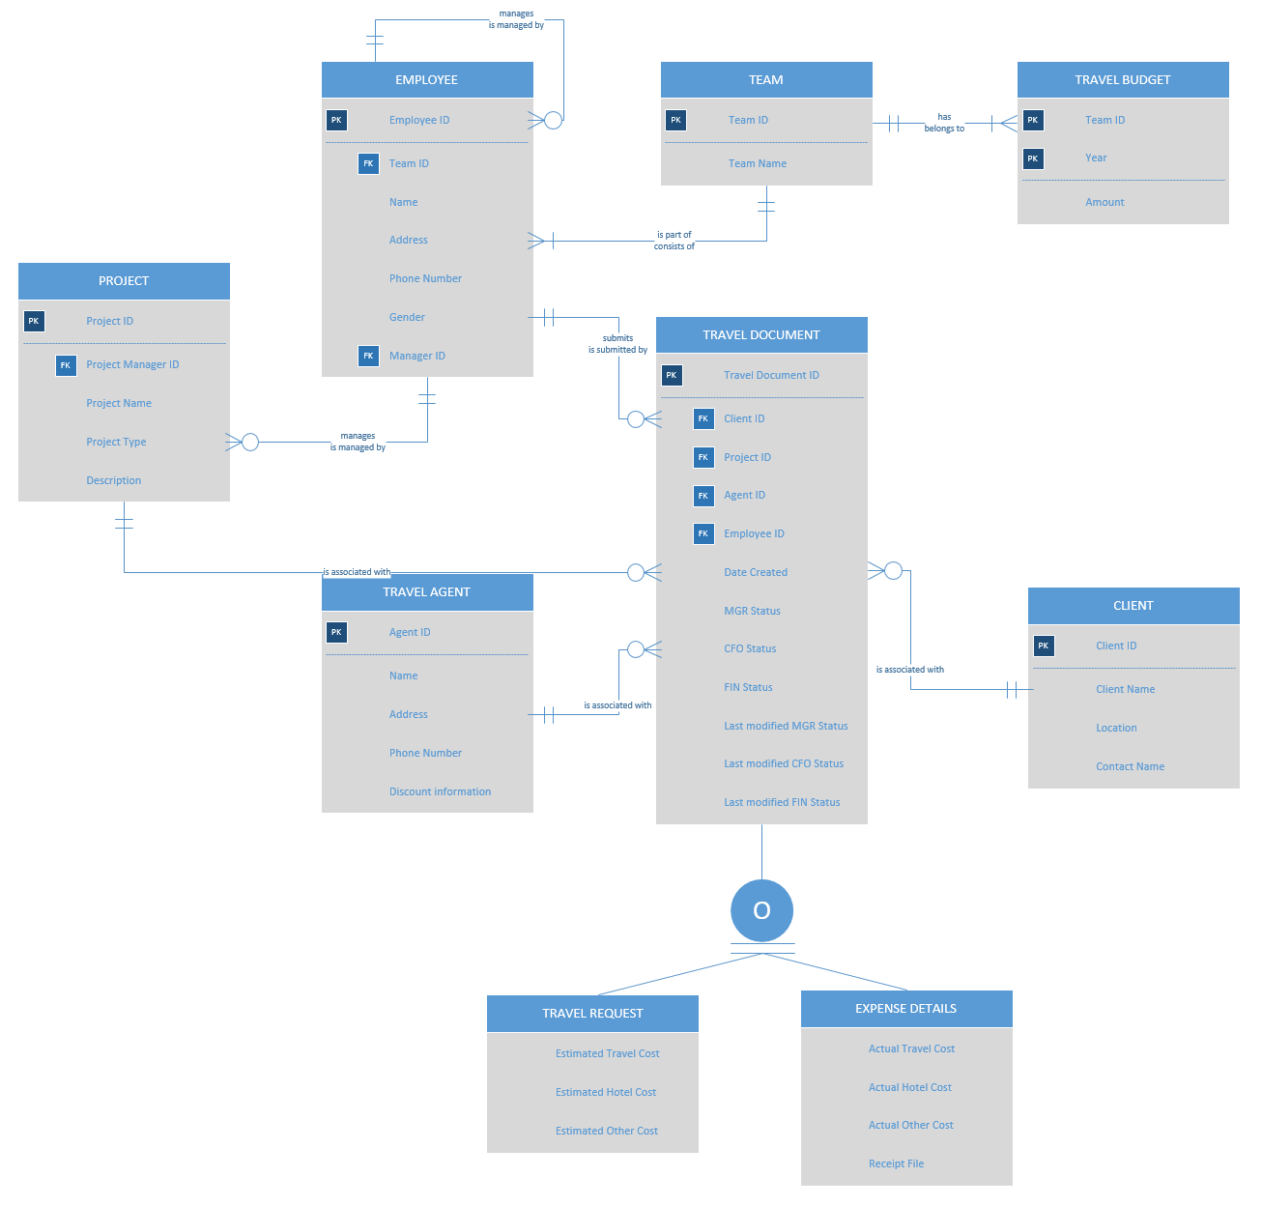

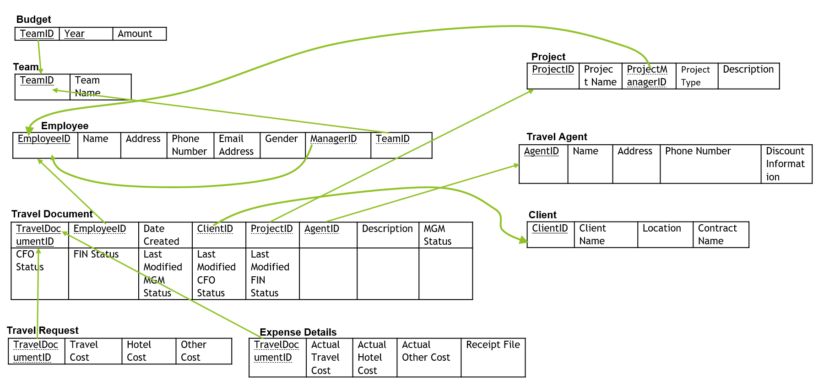

**Project Phase II – Database Design**

1. **Set of related tables:** The entity relationship diagram developed by the team can be transformed into the set of related tables displayed on the previous page.

**Why we did it this way:**

1. We combined the travel request entity with the travel expense entity in a supertype/subtype-relationship, because it shares common attributes/format, saves the same purpose, should be easily comparable (for the manager/CFO)
2. Now, the project manager can have a view on all travel cost that occurred on his project
3. The manager and CFO can compare actual and requested cost much easier
4. The manager and the CFO could easily calculate the percentage of their travel budget already used
5. Many views: Open travel requests and expense reports, cost per client, cost per project, cost per employee, cost per team, etc.